Instruction for Use
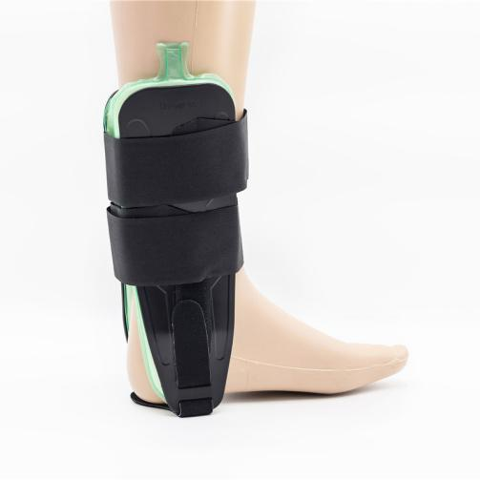

Common Examples of Use

Mild to moderate ankle sprains and strains, support and prevention of further injury after the end of the plaster period, limiting ankle internal and external rotation, and not hindering normal dorsiflexion and plantarflexion.

WARNING:
This product should be given by an treating doctor and applied by a professional. Application should be done with great care to ensure correct fit and efficiency of the brace. For hygiene reasons, it is proposed to be used by a single patient. Recommended product use up to 2 years.

WASHING INSTRUCTIONS:
Check the condition of the product before use. If it is worn off, it needs replacement.
Hand wash with cold water. Use a soft detergent and remove the pads.
Allow to dry on its own. Do not wash it in a washing machine or dry it in a tumble dryer.

